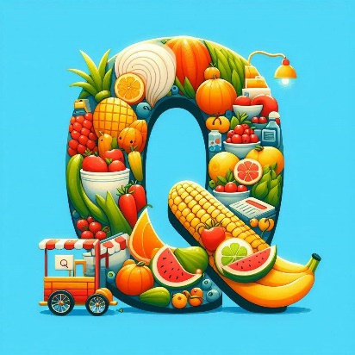
Section A
Farm and Garden Produce
Steward Peter Hird
0429 032 127

Entry Fee | $1 per class/exhibit
Requirements | Completed entry form, entry fees and exhibit.
Exhibit Delivery | Nancy Gray OAM Pavilion Friday 12th September 9:30 am – 12:30 pm
Exhibit & Prize Collection | Sunday 14th September 1pm—3 pm
Conditions of entry: | All exhibits to be grown by exhibitor and judged for commercial value.

VEGETABLES
- One pumpkin (Jap)
- One pumpkin (Jarrahdale)
- One pumpkin (Queensland Blue)
- One pumpkin, any other variety
- Ten stalks rhubarb
- One lettuce
- Ten stalks of spinach or silver beet
- Six carrots
- Bunch of six spring onions
- Cauliflower
- Broccoli
- Any other variety of vegetable not previously mentioned
- 6 years and under - any animal made with fruit, vegetables, and flowers
- 7 years to 12 years – any animal made with fruit, vegetables, and flowers
- Box of Vegetables (Assorted)
Champion Vegetable Exhibit: Ribbon and $10
FRUIT
- Six oranges
- Six lemons
- Six largest grapefruit
- Any other variety of fruit not previously mentioned
Champion Fruit Exhibit: Ribbon and $10
OTHER PRODUCE
- Best dozen export-quality hen eggs
- One jar of honey (light)
- One jar of honey (dark)
- One jar of honey (candy)
Most Successful Exhibitor - Agriculture Section: Ribbon and $10
(2 points for 1st, 1 point for 2nd, 3 points for Champion)
Champion Exhibit - The Kent Trophy (awarded annually) Ribbon

